**ODriveMINI code modification**

Explanation: ODriveMINI cannot directly use the code of ODriveV3.6. Directly using the code of ODriveV3.6 for ODriveMINI will result in its inability to use, so the source code needs to be modified.

1. Firmware\tup.config.default：
2. #CONFIG_BOARD_VERSION=v3.5-24V is modified to  
   CONFIG_BOARD_VERSION=v3.6-56V
3. Rename the tup.config.default file to tup.config.

As shown in the figure.

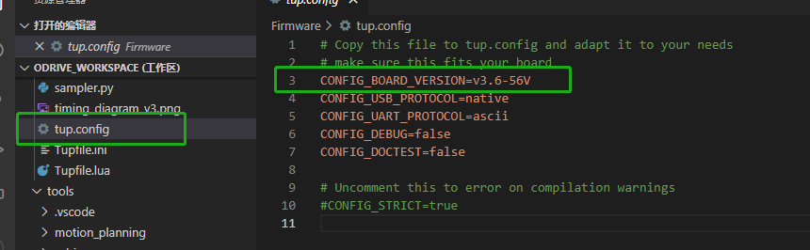

1. Firmware\MotorControl\main.cpp：
2. Comment out lines 273 to 275 of the code.
3. Add the following code on line 276:

axes[0]->motor_.setup();

As shown in the figure.

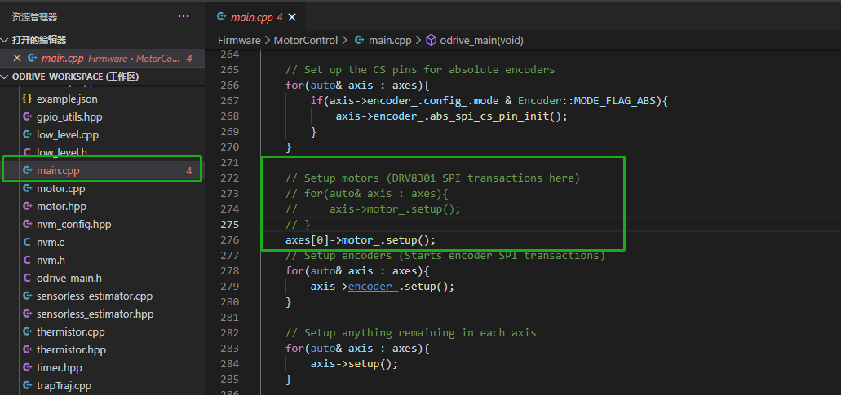

**Modify the following source code to improve the stability of the onboard AS5047P encoder:**

1. Firmware\MotorControl\encoder.cpp：
2. Comment out lines 389 to 391 of the code:

if (ams_parity(rawVal) || ((rawVal >> 14) & 1)) {

return;

}

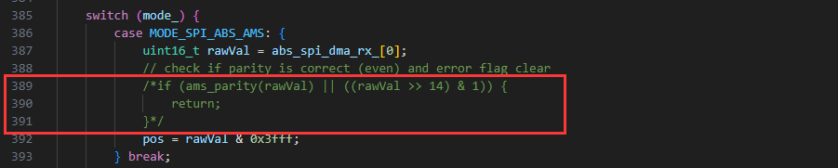

1. Comment out lines 100 to 101 of the code:

if (!is_ready_ && axis_->motor_.config_.motor_type != Motor::MOTOR_TYPE_ACIM)

        config_.pre_calibrated = false;

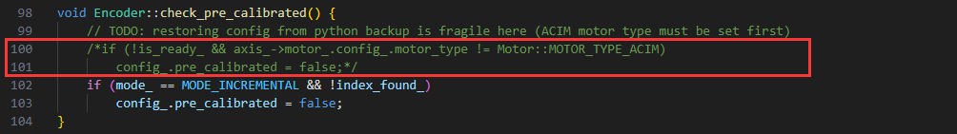

1. Line 13 of the code,

if (config.mode == Encoder::MODE_HALL || config.mode == Encoder::MODE_SINCOS)

is modified to:

if (config.mode != MODE_INCREMENTAL)

